Beverage, Classical Conditioning, and Heart Rate Instructions.
Time: Approximately 40-60 minutes.
Overview: This activity looks at the effect of anticipating and drinking a caffeinated (or other) preferred beverage. You will be asked to calculate your heart rate in beats per minute (BPM) several times for 30 minutes. You will do this before, during, and after drinking your preferred caffeinated (or other) beverage. This experiment should be done within 30 minutes of waking up in the morning before consuming any caffeine or exercising. After finishing the worksheet, you will be entering data in an Excel spreadsheet, comparing your results to past research of many students drinking either a preferred caffeinated beverage or water.
Supplies:
- Before starting the experiment, you will need easy access to a caffeinated beverage that you often drink (e.g., coffee, tea, soda, energy drink, 5-hour energy). If you do not drink caffeinated beverages, use a preferred beverage or water. It is essential that the drink you choose is something that you consume regularly. You will have three minutes to prepare your beverage during the experiment, so be sure you have things prepped for making coffee or tea or have quick access to another beverage. However, do not have the drink with you or within your sight at the beginning of the experiment. You will be describing your caffeinated drink at the end of the assignment.
- A timer. Phones have stopwatches on them, but you can also use a clock or watch as long as it can provide time in seconds. Google provides a stopwatch, but others are easily found online.
- Method for assessing heart rate.
- Worksheet (see below).
Measuring Heart Rate:
There are several ways to measure your heart rate or heartbeats per minute (BPM). Here are three methods in order of their accuracy. You may use any method, but please prioritize in order.
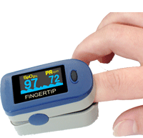
- Best. Heart rate finger monitor. If you already own a heart rate finger monitor or pulse oximeter, then use it for this experiment.


- Second Best. Phone App. There are several free phone apps that provide measures of heart rate by putting your finger on the phone’s camera. After testing several, the following seemed the easiest to use.
  - Heart rate monitor – the app logo is 68 in a red heart

  - AFib Check – the app is a white circle with AFib
- Third Best: Checking pulse with fingers:
With the tip of two fingers, press lightly against your other hand’s wrist or carotid artery (see Figure 1) until you can feel your pulse. Start a timer and count the number of beats for 30 seconds. Double the number of beats that you counted in 30 seconds, and that will give your beats per minute (BPM) or heart rate. This Youtube.com video describes how to determine your heart rate in 30 seconds. https://www.youtube.com/watch?v=AHHr8qNU9QY&ab_channel=HamiltonHealthSciences
Figure 1. Places on your body to check your pulse.
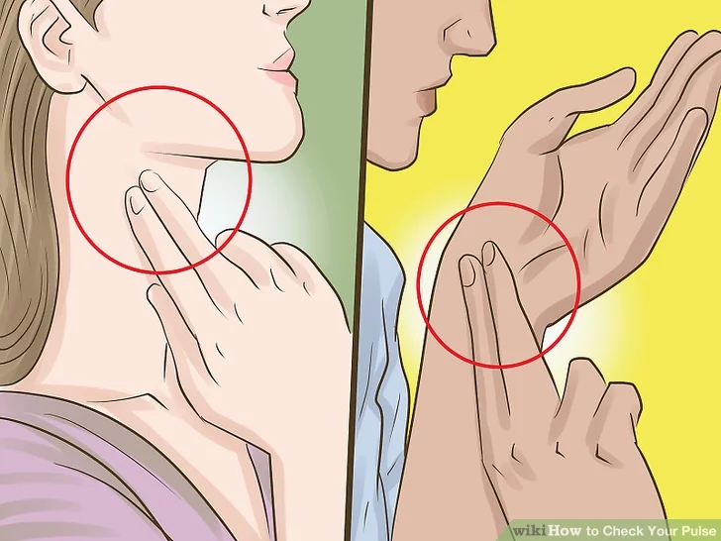
Note: You may have another way of assessing heart rate, which gives you a confident BPM measure, such as a stethoscope, I-watch, or Fitbit. It is okay to use another method; just be sure you report it on the Qualtrics survey.
Practice heart rate in BPM twice with at least one minute between each reading (you will be entering this in the Qualtrics survey):
Practice 1 ___________________(BPM) Method used________________
Practice 2 __________________(BPM) Method used ________________
Before Starting:
- Make sure you are confident and comfortable in your BPM assessment technique.
- Have a caffeinated drink ready but not in front of you.
- Have a stopwatch ready (watch, phone, or computer).
- Sit at a table with a computer or the printed-out worksheet (below).
- Go to the next page and start the experiment.
- After the experiment, enter your data in an Excel spreadsheet.

Worksheet: Do each procedure at the start of each minute
Time (minutes) | Procedures | Heart Beats Per Minute (BPM). Only in shaded cells. In the shaded area only. Leave blank of unable to take a BPM reading.
Start timer  0 | Sit calmly (1 minute)
1 | heartbeat test
2 | Sit calmly
3 | heartbeat test
4 | Sit Calmly
5 | heartbeat test
6 | Retrieve or prepare the drink  If in a can or bottle, open it.
7 | heartbeat test, then finish preparing the drink.
8 | Finish retrieving or preparing the drink or sit calmly
9 | heartbeat test
10 | Sit calmly
11 | heartbeat test
12 | Sit calmly
13 | Smell the drink with one breath. Stop smelling the drink and do a heartbeat test.
14 | Sit calmly
15 | Take a small taste of the drink and do a heartbeat test.
16 | Drink about ½ of the drink
17 | Drink about ½ of what remains of the drink and do a heartbeat test.
18 | Finish the drink and sit calmly
19 | heartbeat test
20 | Sit calmly
21 | heartbeat test
22 | Sit calmly
23 | heartbeat test
24 | Sit calmly
25 | heartbeat test
26 | Sit calmly
27 | heatbeat test
28 | Sit calmly
29 | heatbeat test
Answer questions on next page.

Caffeinated Drink
Type of Drinks (e.g., coffee, tea, Coke, Pepsi, Dr. Pepper, 5-hour energy, Red Bull, water, water or other drink) ________________________
Approximate amount in ounces (oz) (one cup = 8 oz) ____________________________
Estimated caffeine (look on label or see chart below) __________________________
Drink | Caffeine in milligrams (mg)
Water | 0 mg
8 oz regular coffee | 96 mg
8 oz regular brewed tea | 47 mg
8 oz Red Bull | 80 mg
12 oz can cola (Pepsi or Coke) | 34 mg
12 oz Dr. Pepper | 44 mg
12 oz Mt Dew | 55 mg
1 oz Energy shot (5-hour energy) | 230 mg
Here is a link to information about caffeine. https://www.math.utah.edu/~yplee/fun/caffeine.html
Energy drinks differ. This link has information https://cheatdaydesign.com/caffeine-in-energy-drinks/

Answer Questions and Evaluate the Data
Enter your heart rate data into the Excel spreadsheet. Copy your graph and paste it below. Answer the following questions.
- In this experiment, what classical conditioning was assumed to have already taken place because of drinking a beverage often?
- What are the Conditioning Stimulus (CS) ___________ Unconditioned stimulus ___________ Unconditioned Response____________ and the Conditioned response_______________.
- How did your response compare to the average of the 100s of participants who have already completed the experiment? Did you see any difference in your heart rate when you smelled or tasted the beverage?

Paste your Graph Here:

