Brain Anatomy
Scavenger Hunt v2
You’ll be using BrainFacts.org 3D brain. There are three columns. Your job is to fill in the blank spaces (cells) with either a snapshot image, the name of the structure, or a short description (in your own words) of the theoretical function. If the whole column (all three cells) is empty, don’t fill those in because they are created when the table moves to the next page.
Name of structure | Image | Function
Corpus Callosum | 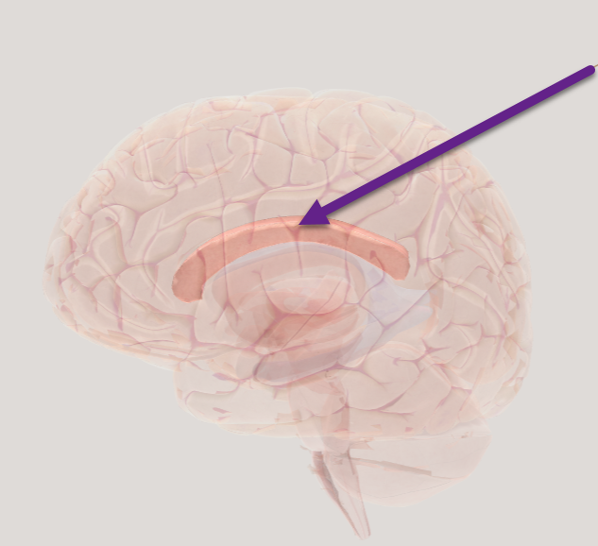 | The corpus callosum is a large track of myelinated axons connecting the left and right hemisphere
Broca’s area
Cingulate cortex | 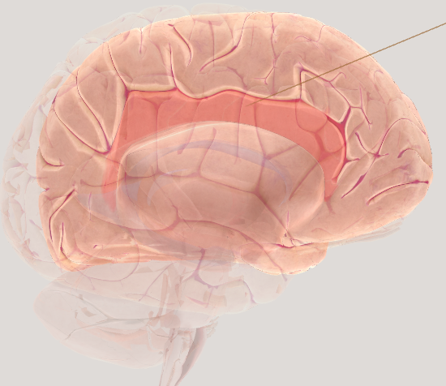
Name of Structure | Screenshot of the image | Function
Cranial nerve X Vagus nerve.
 |  | It produces and releases hormones. It is a key component of the endocrine system. It receives signals from the hypothalamus.
 | 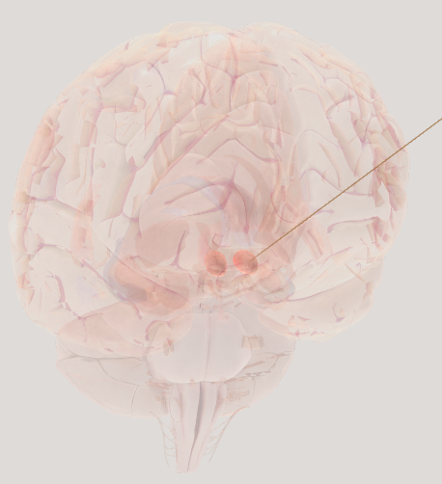 | It controls reward, motivation, and addiction. It receives dopamine signals from neurons in the ventral tegmental area.
 | 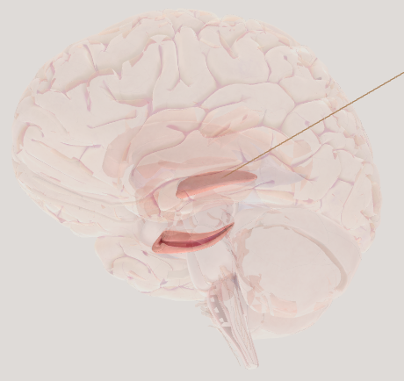
 |  | Located deep in the cerebral cortex in the parietal lobe. Functions in imagination, self-consciousness, and memories of the past.

